Operating systems

Operating systems (OS) where invented to perform specific tasks on electronic devices. The OS is responsible for the communication between the hardware and the application layer. Therefore, it can for example share hardware resources with multiple running tasks, handle hard- and software interrupts or is involved in the memory management on the virtual or even the physical layer.
The first OS was developed by General Motors in 1956 to control their IBM hardware applications. Probably the most well-known OS is Windows since they released an OS with a graphical user interface (GUI) in 1992 which had a significant impact on their popularity that hasn’t vastly decreased since then.
Overall, there are four big OSes, Windows, iOS/macOS from Apple, Android, and Linux. But it must be kept in mind that current Android versions do use the Linux kernel in their OS and that Linux is always just the Kernel, so there is not “the one Linux” version out there. Linux is an open-source application, mostly written in C, which everyone can download and adapt to their likings. Given the adaptability, Linux is widely used in embedded or server applications where it is mandatory to be able to customize the whole OS.
Nowadays most consumers do use Windows or macOS on their personal computers (PC). But if we just look a few years back, the rise of Apple can be seen. In the year 2012, Windows had almost 90 percent of the market while Apple was at about 8 percent. As of now, May 2023, Windows is around 70 percent and Apple is at 17 percent. While Windows lost about 20 percent of its market share, Apple more than doubled theirs. (Source: https://www.statista.com/statistics/268237/global-market-share-held-by-operating-systems-since-2009/ last accessed: 03.05.2023)
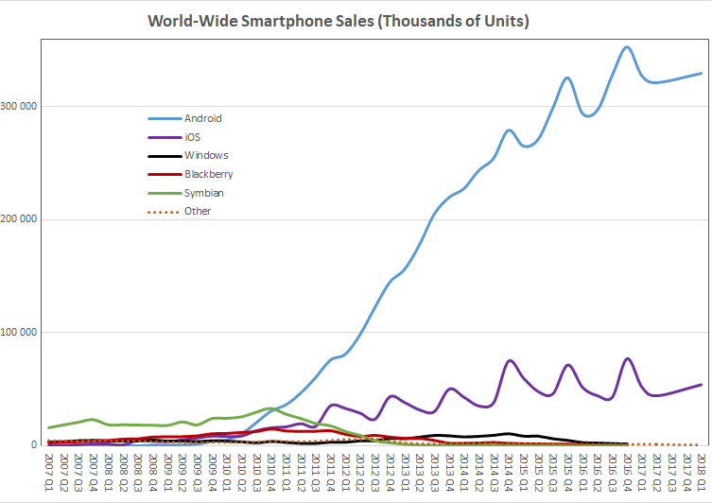
These values are only valid for PCs. The mobile device market is shared a lot more favourably for Apple. There the market shares range at about 70 percent for Android and around 30 percent for Apple. The market shares over time with the different OSes can be seen in figure 1.
Figure 1: World-Wide Smartphone Sales (Source: https://en.wikipedia.org/wiki/Usage_share_of_operating_systems#/media/File:World_Wide_Smartphone_Sales.png last accessed: 03.05.2023)
When it comes to usability, user-friendliness, and pricing there is an ongoing dispute between Apple and Windows, and maybe even Linux, users. When Apple is compared to Windows the first thing that comes to mind is probably the pricing. Apple OSes can only be used on Apple devices whilst Windows OSes can be used on almost any normal PC. So, if you are using Apple’s OS, you must buy an Apple device which is usually up to 1.5 or even 3 times more expensive than a comparable Windows device. But given the fact that Apple OSes run only on Apple devices, their OS can be a lot more specialized for the hardware than Windows will ever be able to and therefore gain a performance boost with comparable hardware specifications. And furthermore, you must buy the Windows OS while the Apple OS is free but bound to a device.
The next important thing about Apple is the user-friendliness. Almost everything that you can run on Apple OSes just works as intended without manipulating any settings. This is not the case when using Windows. Back in the days, every hardware device had to have a specific driver and could not be used without. Nowadays there are generic drivers for most applications but in some cases, you still must adapt or change some settings. This is one of the vast advantages of Apple OSes.
Next let us compare Linux with the other two big players. As earlier mentioned, Linux is just a Kernel. So, Linux in itself isn’t even an OS, but it is the most significant part of an OS. The free accessibility of the source code rendered a whole lot of different distributions for different applications. For example, there is a specialized OS for the Raspberry Pi, Raspbian, based on the Debian Linux OS. Also are there people out there who do use Apples hardware to run Linux on. This is possible because both OSes are derived from the same base OS, BSD/UNIX. The given hardware runs perfectly on both OSes, but you are unable to adapt Apples OS even close to the freedom and scalability you have with Linux.
As conclusion there is no good or bad. It always depends on a variety of parameters like pricing, usage and compatibility when choosing an OS. If you need a home PC and you do not want to investigate a manual at all, probably Apple is the way to go. But if you need a fully customizable home video station, maybe a Linux device fits best in here. And if you want to build your gaming PC you are likely going to use Windows in one of its versions. In the end it is up to you, your personal preferences, and experiences to choose from the lengthy list of operating systems.

FOR PRESENTATIONAL USE ONLY

Questions:
- Which operating systems do you know?
- What is the purpose of an OS?
- Why is Apple better than Windows?
- What is the purpose of Linux?
- Why don’t you use Linux?
- Why is there no Linux OS for your mobile devices?
- Do you know any Google or Google related OSes?
- What is better? iOS or Android?
- Where are OSes where you do not expect them?
- What is your best and/or worst experience/s with OSes?
Backup:
- Gather a list of advantages and disadvantages of different OSes.
- Discuss the advantages. Is one or more advantage even a disadvantage in some cases?

